Faculty Member: Sir Ahsan | Date: 26-12 -24
Lab Engineer: Sir Ali Khalid  Semester: 1ST | Section: C
EE-111: Linear Circuit Analysis
Project Report: Air Quality Monitoring System
 |  | PLO4/CLO4 |  | PLO5/CLO5 | PLO8/CLO6 | PLO9/CLO7
Name | Reg. No | Viva /Quiz / Lab Performance  5 marks | Analysis of data in Lab Report  5 marks | Modern Tool Usage  5 marks | Ethics and Safety  5 marks | Individual and Team Work  5 marks
Fatima Nadir | 503958
Taiba Shafique | 514926
Arooj Zeeshan | 527006
Museera Itlish | 505629

1. Introduction
Air pollution is a serious problem that affects people’s health and the environment. Monitoring air quality is very important to reduce pollution. Our project focuses on creating a system to measure air quality and provide real-time data about pollution levels. This data can help people and authorities take action to improve air quality.
2. Methodology
We designed a system that measures air quality using sensors and displays the information on an LED screen. Here’s how it works:
- Sensors: Detect pollutants like PM2.5, CO2, and NO2.
- Data Collection: Sensors collect real-time data about air pollution.
- Data Processing: The system calculates the Air Quality Index (AQI) based on collected data.
- Communication: Data is sent to the LED display.
- LED Display: Shows AQI levels, pollutant concentrations, or color codes for easy understanding (e.g., green for good air, red for hazardous).
- Alerts: The LED flashes or changes color when pollution exceeds safe levels.
3. Project Details
Code
The code written for our air quality monitoring system integrates multiple sensors, including the DHT11 for temperature and humidity, MQ135 for air quality index, MQ7 for carbon monoxide levels, and a dust sensor for particulate matter detection. Each sensor is interfaced with the Arduino to measure specific environmental parameters, which are then processed and displayed via the Serial Monitor. Threshold values for temperature, humidity, CO levels, and air quality are programmed to trigger alerts using LEDs and a buzzer, ensuring real-time notifications for critical conditions. The system utilizes functions for efficient code structure, with the buzzer acting as an alert mechanism during hazardous conditions. The code also includes noise calibration and data conversions for accurate measurements, ensuring precise monitoring and functionality
#include <DHT.h>
// DHT22 sensor connected to pin 2
#define DHTTYPE DHT22 // Define DHT sensor type and pin
#define DHTPIN 2 // DHT22 (AM2302)
#define MQ135_PIN A2 // MQ135 sensor connected to analog pin A2
#define MQ7_PIN A3 // MQ7 sensor connected to analog pin A3
#define GP2Y_PIN A0 // GP2Y dust sensor connected to digital pin A0
#define BUZZER_PIN 4 // Buzzer connected to pin 4
#define LED_CO_PIN 6 // Yellow LED for CO level connected to pin 6
#define LED_AQI_PIN 5 // Red LED for AQI level connected to pin 5
// Variables for sensor data
float temperature, humidity;
float coLevel, aqi, dustDensity;
DHT dht(DHTPIN, DHTTYPE);
void setup()
{
Serial.begin(9600);
dht.begin();
// Initializing sensor pins
pinMode(GP2Y_PIN, INPUT);
pinMode(BUZZER_PIN, OUTPUT); // Set buzzer pin as output
pinMode(LED_CO_PIN, OUTPUT); // Set LED pin for CO as output
pinMode(LED_AQI_PIN, OUTPUT); // Set LED pin for AQI as output
// Debugging setup
Serial.println("Setup complete. Initializing sensors...");
}
void loop()
{
// Read DHT22 sensor (temperature and humidity)
humidity = dht.readHumidity();
temperature = dht.readTemperature(); // Celsius by default
// Applying calibration for exact temperature reading
temperature = temperature - 8.0; // Adjust for the +4°C error
// Read MQ7 sensor (CO concentration)
int coRaw = analogRead(MQ7_PIN); // Read analog value (CO concentration)
coLevel = coRaw * (5000.0 / 1023.0); // Convert raw value to CO level in ppb
// Read MQ135 sensor (Air quality index)
int aqiRaw = analogRead(MQ135_PIN); // Read analog value (Air quality)
aqi = aqiRaw * (10.0 / 1023.0); // Convert value of AQI to ppm
// Read GP2Y dust sensor (dust concentration)
dustDensity = digitalRead(GP2Y_PIN); // Read dust sensor digital output
// Print sensor data to Serial Monitor
Serial.print("Temperature: ");
Serial.print(temperature);
Serial.print(" °C, Humidity: ");
Serial.print(humidity);
Serial.println(" %");
Serial.print("CO Level (MQ7) in ppb: ");
Serial.println(coLevel);
Serial.print("AQI (MQ135) in ppm: ");
Serial.println(aqi);
Serial.print("Dust Density (GP2Y): ");
if (dustDensity == HIGH)
{
Serial.println("High Dust Concentration");
}
else
{
Serial.println("Low Dust Concentration");
}
// Handle CO level alerts
if (coLevel > 500) { // If CO level is above threshold
Serial.println("Warning: High CO concentration!");
digitalWrite(LED_CO_PIN, HIGH); // Turn on the yellow CO LED
beepBuzzer(); // Start the buzzer beeping
}
else
{
digitalWrite(LED_CO_PIN, LOW); // Turn off the yellow CO LED
}
// Handle AQI alerts
if (aqi > 4) { // Assuming 4 ppm is a poor air quality threshold
Serial.println("Warning: Air Quality is Poor!");
digitalWrite(LED_AQI_PIN, HIGH); // Turn on the red AQI LED
beepBuzzer(); // Start the buzzer beeping
}
else
{
Serial.println("Air Quality is Good.");
digitalWrite(LED_AQI_PIN, LOW); // Turn off the red AQI LED
}
// Handle dust concentration alerts
if (dustDensity == HIGH) {
Serial.println("The air is polluted due to high dust concentration!");
beepBuzzer(); // Start the buzzer beeping
}
// If temperature exceeds 30°C, it's considered high temperature
if (temperature > 30)
{
Serial.println("Warning: High Temperature!");
beepBuzzer(); // Start the buzzer beeping
}
// If none of the thresholds are exceeded, turn off the buzzer
if (coLevel <= 500 && aqi <= 4 && temperature <= 30 && dustDensity == LOW)
{
digitalWrite(BUZZER_PIN, LOW); // Turn off the buzzer
}
delay(2000); // Delay between sensor readings
}
// Function to make the buzzer beep (start and stop)
void beepBuzzer()
{
digitalWrite(BUZZER_PIN, HIGH); // Turn on the buzzer
delay(500); // Buzzer stays on for 500 ms
digitalWrite(BUZZER_PIN, LOW); // Turn off the buzzer
delay(500); // Buzzer stays off for 500 ms
}

Simulation
We tested the system in a simulated environment to verify sensor accuracy and the communication process.
Hardware Pictures
Our setup included the following components:
- Arduino Mega
- DHT 11 Sensor (for temperature and humidity)
- MQ 7 and MQ 135 (for gas detection)
- Dust sensor
- Capacitors, resistors, breadboard, wires, LED lights, and a buzzer
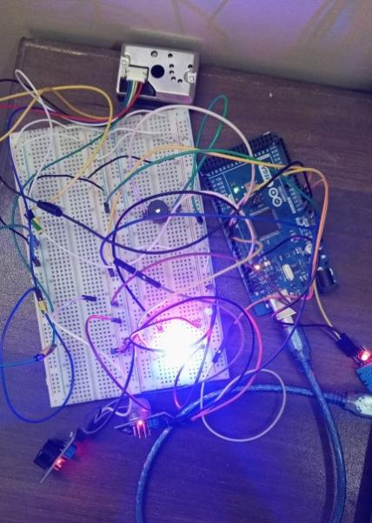
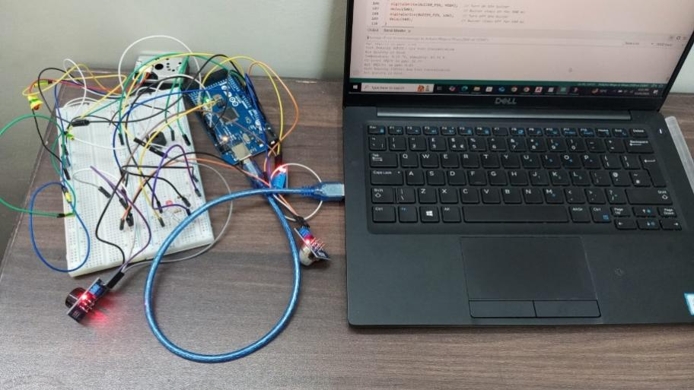
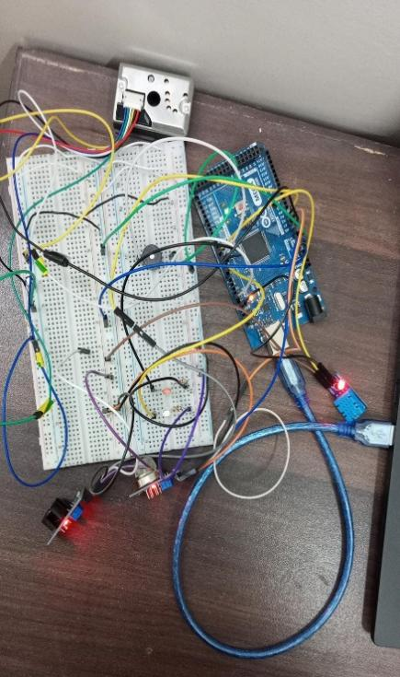
4. Future Scope
This system has potential for further development, such as:
- Smart City Integration: Providing real-time air quality updates for automated actions.
- Better Sensors: Using advanced, compact, and cost-effective sensors for improved accuracy.
- AI and Big Data: Predicting air quality trends and identifying pollution sources.
- Health Monitoring: Linking air quality data with personal health devices.
- Public Awareness: Offering real-time updates through mobile apps and websites.
- Disaster Management: Monitoring air quality during emergencies like wildfires.
5. Contribution of Each Member
- Museera Itlish : Hardware setup , simulation
- Taiba Shafique : Hardware setup , presentation
- Arooj Zeeshan : Coding , Lab report
- Fatima Nadir : Coding , Components shopping
Despite the individual contributions highlighted, every team member played an equally important role in the project's success, ensuring collaboration and shared responsibility throughout its development.
- References
https://circuitdigest.com/microcontroller-projects/iot-air-pollution-monitoring-using-arduino
https://ieeexplore.ieee.org/document/9200053
https://www.ijfmr.com/papers/2023/2/2260.pdf

7. Conclusion
The air quality monitoring system is a step toward solving the air pollution problem. By providing accurate, real-time data, it helps people and policymakers take action to reduce pollution. This project shows the potential for technology to create a cleaner and healthier environment for everyone.

